National Outcomes and Casemix Collection NMDS 2023-24
Exported from METEOR
(AIHW's Metadata Online Registry)
© Australian Institute of Health and Welfare 2024

This product, excluding the AIHW logo, Commonwealth Coat of Arms and any material owned by a third party or protected by a trademark, has been released under a Creative Commons BY 4.0 (CC BY 4.0) licence. Excluded material owned by third parties may include, for example, design and layout, images obtained under licence from third parties and signatures. We have made all reasonable efforts to identify and label material owned by third parties.
You may distribute, remix and build on this website’s material but must attribute the AIHW as the copyright holder, in line with our attribution policy. The full terms and conditions of this licence are available at https://creativecommons.org/licenses/by/4.0/.
Enquiries relating to copyright should be addressed to info@aihw.gov.au.
Enquiries or comments on the METEOR metadata or download should be directed to the METEOR team at meteor@aihw.gov.au.

National Outcomes and Casemix Collection NMDS 2023-24

Identifying and definitional attributes
Metadata item type: | Data Set Specification
METEOR identifier: | 731932
Registration status: | Health, Superseded 06/12/2023
DSS type: | National Minimum Data Set (NMDS)
Scope: | The purpose of the National Outcomes and Casemix Collection (NOCC) national minimum data set (NMDS) is to collect data on the mental health-related treatment of consumers of public specialised mental health services, and information on whether consumers improve following mental health care. A set of clinical measures are used to gather information about clinical mental health status and functioning. Measures can be completed by:  - clinicians about the consumer (known as clinician-rated),  - the consumer about themselves (consumer-rated), and  - families and carers about the consumer (carer-rated).  Casemix information, describing the cohort of users of this service, such as mental health legal status, is also collected.  All consumers who receive clinical care in public specialised mental health services should be included in the NOCC, including psychiatric inpatient, residential and ambulatory (non-admitted) settings.

Collection and usage attributes
Statistical unit: | Collection occasion
Guide for use: | This NMDS combines with the National Outcomes and Casemix Collection NBEDS 2023-24 to comprise all data collection for the National Outcomes and Casemix Collection (NOCC). The data for NOCC are collected differently across states and territories and collection of some data items is either optional or conditional on age, setting, and occasion type. As such, the NOCC is split into this NMDS for mandatory items and an adjunct NBEDS for items not collected consistently across all jurisdictions. The data set specifications are used in conjunction to report total outcomes and casemix data.  Outcome measures attempt to determine whether a change has occurred for a consumer as a result of mental health care and to assess the type and magnitude of that change. By using a range of outcome measures, consumers and clinicians can work together to map the journey of recovery over time. The NOCC measures contribute to the development of clinical practice, aiming to improve the quality of care for consumers of Australia’s public sector mental health services.  Outcome measures can assist consumers in considering options for their care and treatment and support the development of a therapeutic relationship between the clinician and the consumer. The measures can also be used by clinicians to monitor the progress of the consumer, evaluate the effectiveness of treatments and thereby provide information that will assist decisions about clinical practices. The outcome measures can also be used by team leaders and service managers to better understand the needs of consumers, to plan for the allocation of resources and to identify where service improvements are required.  Casemix classifications provide a consistent method of classifying types of patients, their treatment and associated outcomes. In popular usage, casemix refers to the mix of types of patients treated by a hospital or other health care facility (Eagar and Hindle 1994). NOCC casemix data describes the various groupings of the specialised mental health service treatments based on the type and mix of the patients treated, including the expected outcome of treatment (e.g., improvement or maintenance), grouping by diagnostic cohort (e.g., outcomes for people depending on their mental health diagnosis) and whether or not the patient is receiving treatment voluntarily. Casemix measures collected for the NOCC are:  - Mental Health Legal Status  - Phase of Care  - Primary Diagnosis  - Additional Diagnosis  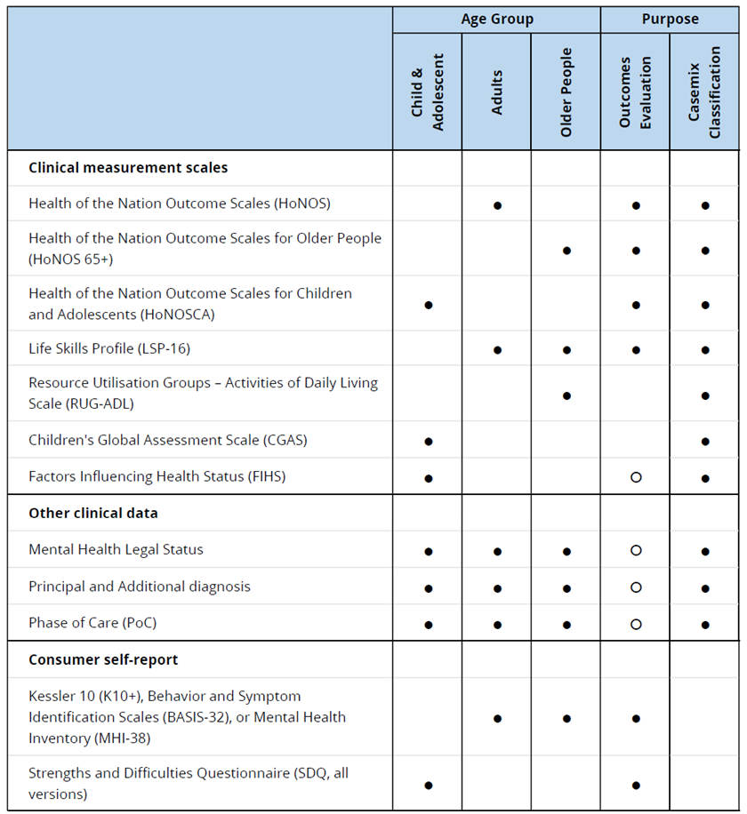  More detailed information about each measure can be found in Mental Health National Outcomes and Casemix Collection: Overview of Clinician-Rated and Consumer Self-Report Measures V1.50 (Australian Mental Health Outcomes and Classifications Network, 2021).  These measures are collected by services according to a set of protocols - at specified times and points in service delivery. These protocols are described in Mental Health National Outcomes and Casemix Collection: Technical specification of State and Territory reporting requirements, version: 2.10 (Australian Mental Health Outcomes and Classifications Network, 2022).
Collection methods: | The NOCC protocol defines the minimum requirements and should not be interpreted as confining participating states and territories to those requirements. Additionally, local services may elect to collect additional measures or to increase the frequency of ratings.  Casemix requirements need key data to be collected only once during each episode of care to allow the episode to be adequately described and classified. From the casemix perspective, the only issue is to ensure that the information is collected at the most appropriate point within the overall episode.  Measurement of consumer outcomes by definition presumes a comparison over time and requires data to be collected on at least two sequential occasions in order to allow assessment of change in the consumer’s health status.  Measures can be consumer rated or clinician rated and should be collected using a matrix of collection occasion, setting and age group:  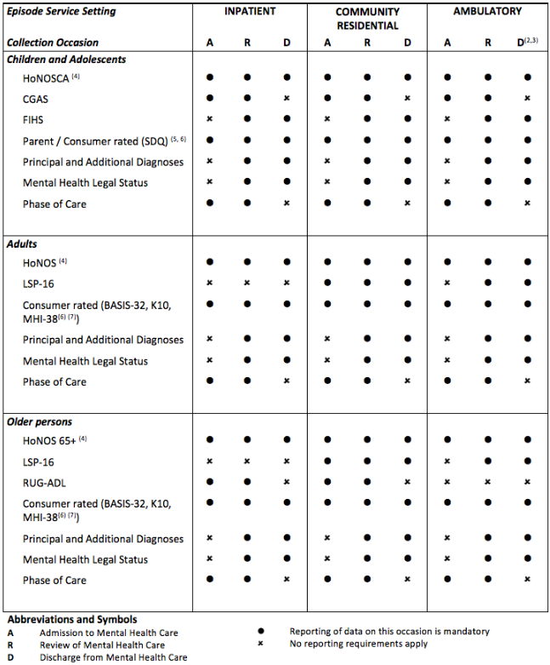  See NOCC collection protocol (Australian Mental Health Outcomes and Classifications Network, 2021) for more details.
Implementation start date: | 01/07/2023
Implementation end date: | 30/06/2024
Comments: | Glossary items  Glossary terms that are relevant to this national minimum data set are included here.  Admission  Admitted patient mental health care service  Ambulatory care  Ambulatory mental health care service  Gender  Geographic indicator  Mental health care  Mental health consumer  Mental health phase of care  Resident  Residential mental health care service  Resource Utilisation Groups—Activities of Daily Living  Separation  Sex

Source and reference attributes
Submitting organisation: | Australian Institute of Health and Welfare
Reference documents: | Australian Mental Health Outcomes and Classification Network 2022. Mental Health National Outcomes and Casemix Collection: Technical specification of State and Territory reporting requirements, Version 2.10. Viewed 25 July 2022 https​:​/​/docs​.validator​.com​.au​/nocc​/02​.10​/  Australian Mental Health Outcomes and Classification Network 2021. Mental Health National Outcomes and Casemix Collection: Overview of Clinician-Rated and Consumer Self-Report Measures V.2.10. Viewed 25 July 2022 https​:​/​/www​.amhocn​.org​/sites​/default​/files​/publication​_files​/nocc​_clinician​_and​_self​-report​_measures​_overview​_v2​.1​_20210913​_1​.pdf  Eagar K and Hindle D (1994). Casemix in Australia: an overview. The National Casemix Education Series No.2. Canberra: Department of Human Services and Health.

Relational attributes
Related metadata references: | Has been superseded by National Outcomes and Casemix Collection NMDS 2024-25  Health, Standard 06/12/2023  See also Mental health establishments NMDS 2023–24  Health, Superseded 06/12/2023  See also National Outcomes and Casemix Collection 2021–2022; National Outcomes and Casemix Database, 2023; Quality Statement  AIHW Data Quality Statements, Standard 12/10/2023  See also National Outcomes and Casemix Collection NBEDS 2023-24  Health, Superseded 06/12/2023
Implementation in Data Set Specifications: | National Outcomes and Casemix Collection NBEDS 2023-24  Health, Superseded 06/12/2023  Implementation start date: 01/07/2023  Implementation end date: 30/06/2024

Metadata items in this Data Set Specification
Seq No. | Metadata item | Obligation | Max occurs
- | Address—statistical area, level 2 (SA2) code (ASGS Edition 3) N(9)  DSS specific information:  For the National Outcomes and Casemix Collection (NOCC) NMDS, this data element is collecting address information of the service provider. | Mandatory | 1
- | Collection occasion—collection reason, healthcare code N(N) | Mandatory | 1
- | Collection occasion—identifier, X[X(29)] | Mandatory | 1
- | Collection occasion—reference date, DDMMYYYY  DSS specific information:  For use in the National Outcomes and Casemix Collection (NOCC), this is the reference date for all data collected at any given collection occasion defined as the date on which the collection occasion (admission, review, or discharge) occurred.  The collection occasion date should be distinguished from the actual date of completion of individual measures that are required at the specific occasion. In practice, the various measures may be completed by clinicians and consumers over several days. For national reporting and statistical purposes, a single date is required which ties all the standardised measures and other data items together in a single collection occasion. The actual collection dates of the individual data items and standard measures may be collected locally but is not required in the national reporting extract.  For data collected at the beginning of an episode of mental health care, the collection occasion date is referred to as the admission date. For data collected at end of an episode of mental health care, the collection occasion date is referred to as the discharge date. For data collected at review during an ongoing episode of mental health care, the collection occasion date is referred to as the review date.  A special requirement applies in the case of inpatient episodes to facilitate record matching with corresponding records collected under the Admitted patient care NMDS 2023–24. For admission to inpatient episodes, the collection occasion date should be the date of admission as recorded in the NMDS data set. For discharge from inpatient episodes, the collection occasion date should be the date of separation as recorded in the NMDS data set. | Mandatory | 1
- | Episode of care—additional diagnosis, code (ICD-10-AM Twelfth edition) ANN{.N[N]}  Conditional obligation:  This data element is only to be reported if the collection occasion results in more than one diagnosis code being allocated. | Conditional | 99
- | Episode of care—mental health legal status, code N | Mandatory | 1
- | Episode of care—principal diagnosis, code (ICD-10-AM Twelfth edition) ANN{.N[N]} | Mandatory | 1
- | Episode of mental health care—service delivery setting, code N  DSS specific information:  For the National Outcomes and Casemix Collection (NOCC), this data element is intended to describe the setting in which care took place, regardless of the formal designation of that service unit type.  It does not have to correspond to the service unit type (Specialised mental health service organisation—service delivery setting, code N) data element reported on the collection occasion record. The service unit type item is an attribute of the service unit, and this data element is an attribute of the episode of mental health care. | Mandatory | 1
- | Establishment—Australian state/territory identifier, code N | Mandatory | 1
- | Establishment—region identifier, X[X] | Mandatory | 1
- | Establishment—region name, text XXX[X(57)] | Mandatory | 1
- | Establishment—sector, code N | Mandatory | 1
- | Establishment—service unit cluster identifier, XXXXX  Conditional obligation:  For use in the National Outcomes and Casemix Collection (NOCC), this data element applies when the service provision setting is Ambulatory mental health care service or Residential mental health care service.  Data must be collected for either this data element or Hospital—hospital identifier, XXXXX.  DSS specific information:  For use in the National Outcomes and Casemix Collection (NOCC), for admitted patient service units, the hospital cluster identifier should be identical to that used to identify the hospital to which the service unit belongs. For ambulatory and residential services units, where there is no service unit cluster, the hospital cluster identifier is to be reported as "00000" and the hospital cluster name would use the relevant organisation name. | Conditional | 1
- | Establishment—service unit cluster name, text XXX[X(97)]  Conditional obligation:  For use in the National Outcomes and Casemix Collection (NOCC), this data element applies when the service provision setting is Ambulatory mental health care service or Residential mental health care service.  Data must be collected for either this data element or Hospital—hospital name, text XXX[X(97)].  DSS specific information:  For use in the National Outcomes and Casemix Collection (NOCC), this data element collects the common name used to identify the service unit. For admitted patient service units, the hospital cluster name should be identical to that used to identify the hospital to which the service unit belongs. For ambulatory and residential services units, where there is no service unit cluster, the hospital cluster name would use the relevant organisation name. | Conditional | 1
- | Hospital—hospital identifier, XXXXX  Conditional obligation:  For use in the National Outcomes and Casemix Collection (NOCC), this data element applies when the service provision setting is Admitted patient mental health care service.  Data must be collected for either this data element or Establishment—service unit cluster identifier, XXXXX.  DSS specific information:  For use in the National Outcomes and Casemix Collection (NOCC), for admitted patient service units, the hospital cluster identifier should be identical to that used to identify the hospital to which the service unit belongs. For ambulatory and residential services units, where there is no service unit cluster, the hospital identifier is to be reported as "00000" and the hospital cluster would use the relevant organisation name. | Conditional | 1
- | Hospital—hospital name, text XXX[X(97)]  Conditional obligation:  For use in the National Outcomes and Casemix Collection (NOCC), this data element applies when the service provision setting is Admitted patient mental health care service.  Data must be collected for either this data element or Establishment—service unit cluster name, text XXX[X(97)].  DSS specific information:  For use in the National Outcomes and Casemix Collection (NOCC), this data element collects the common name used to identify the service unit. For admitted patient service units, the hospital cluster name should be identical to that used to identify the hospital to which the service unit belongs. For ambulatory and residential services units, where there is no service unit cluster, the hospital cluster name would use the relevant organisation name. | Conditional | 1
- | Person—age range, age group code N | Mandatory | 1
- | Person—area of usual residence, statistical area level 2 (SA2) code (ASGS Edition 3) N(9) | Mandatory | 1
- | Person—country of birth, code (SACC 2016) NNNN | Mandatory | 1
- | Person—date of birth, DDMMYYYY | Mandatory | 1
- | Person—Indigenous status, code N | Mandatory | 1
- | Person—person identifier, XXXXXX[X(14)] | Mandatory | 1
- | Person—sex, code X | Mandatory | 1
- | Specialised mental health service organisation—organisation identifier, XXXX  DSS specific information:  For use in the National Outcomes and Casemix Collection (NOCC), this organisation identifier should map to the identifiers used in data reported for the Mental health establishments NMDS 2023–24. | Mandatory | 1
- | Specialised mental health service organisation—organisation name, text XXX[X(97)]  DSS specific information:  For use in the National Outcomes and Casemix Collection (NOCC), this organisation name should map to the identifiers used in data reported for the Mental health establishments NMDS 2023–24. | Mandatory | 1
- | Specialised mental health service organisation—service delivery setting, code N  DSS specific information:  For use in the National Outcomes and Casemix Collection (NOCC), this data element describes the service setting in which care is most typically provided by the service unit.  It does not have to correspond to the episode of service setting (Episode of mental health care—service delivery setting, specialised mental health service setting code N) data element reported on the collection occasion record. The service unit type item is an attribute of the service unit, and the episode of service setting data element is an attribute of the episode of mental health care. | Mandatory | 1
- | Specialised mental health service—admitted patient care program type, code N  Conditional obligation:  For the National Outcomes and Casemix Collection (NOCC), complete where service delivery setting (Specialised mental health service organisation—service delivery setting, code N (aihw.gov.au)) is CODE 1 "admitted patient stay".  DSS specific information:  For the National Outcomes and Casemix Collection (NOCC), additional supplementary values are available for use:  8: Not applicable  9: Not available | Conditional | 1
- | Specialised mental health service—admitted patient service unit identifier, XXXXXX  Conditional obligation:  For use in the National Outcomes and Casemix Collection (NOCC), this data element applies when the service provision setting is Admitted patient mental health care service.  Data must be collected for either this data element or one of Specialised mental health service—ambulatory service unit identifier, XXXXXX or Specialised mental health service—residential service unit identifier, XXXXXX.  DSS specific information:  For the National Outcomes and Casemix Collection (NOCC), admitted patient service units should be differentiated by target population (general, older persons, child and adolescent, youth, and forensic) and program type (acute vs other). For example, if a hospital had separate wards for child and adolescent and general adult populations, these should be reported as separate service units. Similarly, if the hospital provided separate wards for older persons acute and older person other program types, this would require separate service units to be identified (that is, defined by the program type as well as the target population). The overarching principle is that the same service unit identification policy must be applied to the admitted patient service units data reported under the NOCC and the Mental health establishments NMDS 2023–24.  States and territories should ensure that the service unit identifiers are unique across all service unit types (i.e., admitted patient, ambulatory care, residential care services). Identifiers used to supply data to NOCC in respect of a particular service unit should be stable over time - that is, unless there has been a significant change to the unit, the same identifier should be used from year to year of reporting.  The service unit identifier is reported at each collection occasion.  Ideally, where a mental health service provides mixed service types (e.g., overnight inpatient care as well as ambulatory care), each component will be defined as a separate service unit and assigned a unique service unit identifier. | Conditional | 1
- | Specialised mental health service—admitted patient service unit name, text XXX[X(97)]  Conditional obligation:  For use in the National Outcomes and Casemix Collection (NOCC), this data element applies when the service provision setting is admitted patient mental health care service.  Data must be collected for either this data element or one of Specialised mental health service—ambulatory service unit name, text XXX[X(97)] or Specialised mental health service—residential service unit name, text XXX[X(97)].  DSS specific information:  For the National Outcomes and Casemix Collection (NOCC), admitted patient service units should be differentiated by target population (general, older persons, child and adolescent, youth, and forensic) and program type (acute vs other). For example, if a hospital had separate wards for child and adolescent and general adult populations, these should be reported as separate service units. Similarly, if the hospital provided separate wards for older persons acute and older person other program types, this would require separate service units to be identified (i.e., defined by the program type as well as the target population). The overarching principle is that the same service unit identification policy must be applied to the admitted patient service units' data reported under reported under the NOCC and the Mental health establishments NMDS 2023–24.  The service unit name is reported at each collection occasion.  Ideally, where a mental health service provides mixed service types (e.g., overnight inpatient care as well as ambulatory care), each component will be defined as a separate service unit. | Conditional | 1
- | Specialised mental health service—ambulatory service unit identifier, XXXXXX  Conditional obligation:  For use in the National Outcomes and Casemix Collection (NOCC), this data element applies when the service provision setting is Ambulatory mental health care service.  Data must be collected for either this data element or one of Specialised mental health service—admitted patient service unit identifier, XXXXXX or Specialised mental health service—residential service unit identifier, XXXXXX.  DSS specific information:  For the National Outcomes and Casemix Collection (NOCC), ambulatory service units should be differentiated by target population (general, older persons, child and adolescent, youth, and forensic). Where an organisation provides multiple teams serving the same target population, these may be grouped and reported as a single service unit or identified as individual service unit in their own right. Where possible, it is also desirable that residential service units identified in NOCC data correspond directly on a one-to-one basis to those reported in the Community mental health care NMDS 2023–24.  States and territories should ensure that the service unit identifiers are unique across all service unit types (i.e., admitted patient, ambulatory care, residential care services). Identifiers used to supply data to NOCC in respect of a particular service unit should be stable over time - that is, unless there has been a significant change to the unit, the same identifier should be used from year to year of reporting.  The service unit identifier is reported at each collection occasion.  Ideally, where a mental health service provides mixed service types (e.g., overnight inpatient care as well as ambulatory care), each component will be defined as a separate service unit and assigned a unique service unit identifier. | Conditional | 1
- | Specialised mental health service—ambulatory service unit name, text XXX[X(97)]  Conditional obligation:  For use in the National Outcomes and Casemix Collection (NOCC), this data element applies when the service provision setting is Ambulatory mental health care service.  Data must be collected for either this data element or one of Specialised mental health service—admitted patient service unit name, text XXX[X(97)] or Specialised mental health service—residential service unit name, text XXX[X(97)].  DSS specific information:  For use in the National Outcomes and Casemix Collection (NOCC), ambulatory service units should be differentiated by target population (general, older persons, child and adolescent, youth, and forensic). Where an organisation provides multiple teams serving the same target population, these may be grouped and reported as a single service unit or identified as individual service units in their own right. Where possible, it is also desirable that residential service units identified in NOCC data correspond directly on a one-to-one basis to those reported in the Community mental health care NMDS 2023–24. | Conditional | 1
- | Specialised mental health service—co-location with acute care hospital, code N  DSS specific information:  For the National Outcomes and Casemix Collection (NOCC), additional supplementary values are available for use:  8: Not applicable | Mandatory | 1
- | Specialised mental health service—residential service unit identifier, XXXXXX  Conditional obligation:  For use in the National Outcomes and Casemix Collection (NOCC), this data element applies when the service provision setting is Residential mental health care service.  Data must be collected for either this data element or one of Specialised mental health service—admitted patient service unit identifier, XXXXXX or Specialised mental health service—ambulatory service unit identifier, XXXXXX.  DSS specific information:  For the National Outcomes and Casemix Collection (NOCC), residential service units should be differentiated by target population (general, older persons, child and adolescent, youth, and forensic). Where possible, it is also desirable that residential service units identified in NOCC data correspond directly on a one-to-one basis to those reported in the Residential mental health care NMDS 2023–24.  States and territories should ensure that the service unit identifiers are unique across all service unit types (i.e., admitted patient, ambulatory care, residential care services). Identifiers used to supply data to NOCC in respect of a particular service unit should be stable over time - that is, unless there has been a significant change to the unit, the same identifier should be used from year to year of reporting.  The service unit identifier is reported at each collection occasion.  Ideally, where a mental health service provides mixed service types (e.g., overnight inpatient care as well as ambulatory care), each component will be defined as a separate service unit and assigned a unique service unit identifier. | Conditional | 1
- | Specialised mental health service—residential service unit name, text XXX[X(97)]  Conditional obligation:  For use in the National Outcomes and Casemix Collection (NOCC), this data element applies when the service provision setting is Residential mental health care service.  Data must be collected for either this data element or one of Specialised mental health service—admitted patient service unit name, text XXX[X(97)] or Specialised mental health service—ambulatory service unit name, text XXX[X(97)].  DSS specific information:  For use in the National Outcomes and Casemix Collection (NOCC), residential service units should be differentiated by target population (general, older persons, child and adolescent, youth, and forensic). Where possible, it is also desirable that residential service units identified in NOCC data correspond directly on a one-to-one basis to those reported in the Residential mental health care NMDS 2023–24. | Conditional | 1
- | Specialised mental health service—target population group, code N | Mandatory | 1

