Person—distress status in past week, distress thermometer code N[N]
Exported from METEOR
(AIHW's Metadata Online Registry)
© Australian Institute of Health and Welfare 2024

This product, excluding the AIHW logo, Commonwealth Coat of Arms and any material owned by a third party or protected by a trademark, has been released under a Creative Commons BY 4.0 (CC BY 4.0) licence. Excluded material owned by third parties may include, for example, design and layout, images obtained under licence from third parties and signatures. We have made all reasonable efforts to identify and label material owned by third parties.
You may distribute, remix and build on this website’s material but must attribute the AIHW as the copyright holder, in line with our attribution policy. The full terms and conditions of this licence are available at https://creativecommons.org/licenses/by/4.0/.
Enquiries relating to copyright should be addressed to info@aihw.gov.au.
Enquiries or comments on the METEOR metadata or download should be directed to the METEOR team at meteor@aihw.gov.au.

Person—distress status in past week, distress thermometer code N[N]

Identifying and definitional attributes
Metadata item type: | Data Element
Short name: | Distress status in past week
Synonymous names: | Distress thermometer
METEOR identifier: | 483594
Registration status: | Health, Standard 04/02/2015
Definition: | The level of distress experienced by the person in the past week, as represented by a code.

Data element concept attributes

Identifying and definitional attributes
Data element concept: | Person—distress status in past week
METEOR identifier: | 483587
Registration status: | Health, Standard 04/02/2015
Definition: | The level of distress experienced by the person over the past week.
Object class: | Person
Property: | Distress status in past week

Source and reference attributes
Submitting organisation: | Cancer Australia

Value domain attributes

Identifying and definitional attributes
Value domain: | Distress thermometer code N[N]
METEOR identifier: | 573491
Registration status: | Health, Standard 04/02/2015
Definition: | A code set representing the values on the distress thermometer.

Representational attributes
Representation class: | Code
Data type: | Number
Format: | N[N]
Maximum character length: | 2

Collection and usage attributes
Guide for use: | Using a visual distress thermometer (see the Collection methods section below for an example), ask the person to indicate the level of distress that they have experienced in the past week on a scale from 0-10, where 0 indicates ‘No distress’ and 10 indicates ‘Extreme distress’.  Valid values are 0 to 10.
Collection methods: | Using the image below as a reference, patients are given the instruction “Circle the number (0-10) that best describes how much distress you have been experiencing in the past week including today" and are given the opportunity to circle a number on the paper or an electronic distress thermometer.  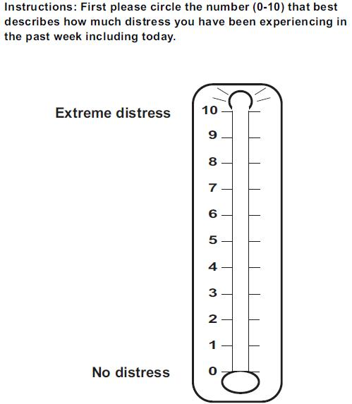
Comments: | The distress thermometer has been found to have reasonable sensitivity and specificity for general distress, depression and anxiety (Mitchell, 2007) and to be comparable, as a screening tool, with longer measures of psychological symptoms (Mitchell, 2010). It should be noted that while the distress thermometer is valuable as a screening tool, it is not a replacement for careful clinical assessment and management.  Reproduced with permission from the NCCN Clinical Practice Guidelines in Oncology (NCCN Guidelines®) for Distress Management (V.3.2012). © 2012 National Comprehensive Cancer Network, Inc. Available at: NCCN.org. Accessed [June 12, 2012]. To view the most recent and complete version of the NCCN Guidelines®, go on-line to NCCN.org.

Source and reference attributes
Submitting organisation: | Cancer Australia
Reference documents: | Mitchell AJ (2007). Pooled results from 38 analyses of the accuracy of distress thermometer and other ultra-short methods of detecting cancer-related mood disorder. Journal of Clinical Oncology,25:4670-4681.  Mitchell AJ (2010). Short Screening Tools for Cancer-Related Distress: A Review and Diagnostic Validity Meta-Analysis. Journal of the National Comprehensive Cancer Network,8:487-494.  National Comprehensive Cancer Network (2012). NCCN Clinical Practice Guidelines in Oncology: Distress Management. Retrieved from http://www.nccn.org/professionals/physician_gls/f_guidelines.asp

Data element attributes

Collection and usage attributes
Guide for use: | The visual distress thermometer is used for assessing the person's level of distress, generally within a clinical setting.

Source and reference attributes
Submitting organisation: | Cancer Australia
Reference documents: | Mitchell AJ 2007. Pooled results from 38 analyses of the accuracy of distress thermometer and other ultra-short methods of detecting cancer-related mood disorder. Journal of Clinical Oncology, 25:4670-4681.  Mitchell AJ 2010. Short Screening Tools for Cancer-Related Distress: A Review and Diagnostic Validity Meta-Analysis. Journal of the National Comprehensive Cancer Network, 8:487-494.  National Comprehensive Cancer Network 2012. NCCN Clinical Practice Guidelines in Oncology: Distress Management. Viewed 17 September 2014, http://www.nccn.org/professionals/physician_gls/f_guidelines.asp

Relational attributes
Implementation in Data Set Specifications: | Adolescent and young adult cancer (clinical) DSS  Health, Superseded 14/05/2015  DSS specific information:  It is recommended that this item is collected within 2 weeks of diagnosis, 6-8 weeks post diagnosis, and 6 months post diagnosis. Any further screening should take place at the clinician’s discretion or the patient’s request. At a minimum, this should occur at remission, recurrence, or progression.  For more information regarding the use of the distress thermometer with Adolescent and Young Adults with cancer, please consult the Psychosocial Management of AYAs diagnosed with cancer: Guidance for health professionals (http://wiki.cancer.org.au/australia/  COSA:Psychosocial_management_of_AYA_cancer_patients/  Information_and_resources).  Adolescent and young adult cancer (clinical) NBPDS  Health, Standard 14/05/2015  DSS specific information:  It is recommended that this item is collected within 2 weeks of diagnosis, 6-8 weeks post diagnosis, and 6 months post diagnosis. Any further screening should take place at the clinician’s discretion or the patient’s request. At a minimum, this should occur at remission, recurrence, or progression.  For more information regarding the use of the distress thermometer with Adolescent and Young Adults with cancer, please consult the Psychosocial Management of AYAs diagnosed with cancer: Guidance for health professionals (http://wiki.cancer.org.au/australia/  COSA:Psychosocial_management_of_AYA_cancer_patients/  Information_and_resources).

