Early childhood education and care worker cluster
Exported from METEOR
(AIHW's Metadata Online Registry)
© Australian Institute of Health and Welfare 2024

This product, excluding the AIHW logo, Commonwealth Coat of Arms and any material owned by a third party or protected by a trademark, has been released under a Creative Commons BY 4.0 (CC BY 4.0) licence. Excluded material owned by third parties may include, for example, design and layout, images obtained under licence from third parties and signatures. We have made all reasonable efforts to identify and label material owned by third parties.
You may distribute, remix and build on this website’s material but must attribute the AIHW as the copyright holder, in line with our attribution policy. The full terms and conditions of this licence are available at https://creativecommons.org/licenses/by/4.0/.
Enquiries relating to copyright should be addressed to info@aihw.gov.au.
Enquiries or comments on the METEOR metadata or download should be directed to the METEOR team at meteor@aihw.gov.au.

Early childhood education and care worker cluster

Identifying and definitional attributes
Metadata item type: | Data Set Specification
METEOR identifier: | 444715
Registration status: | Early Childhood, Superseded 09/03/2012
DSS type: | Data Element Cluster
Scope: | These data items are used in conjunction with each other to describe the workers employed in early childhood education and care services.  The following diagram shows the sequencing of the data items for workers for data collection purposes, it is not outlining the sequencing for derivation purposes. The sequencing of the data items will capture information for:  - the main type of work activity and main role for paid workers during the reference period;  - the field and level of highest qualification relevant to ECEC for paid contact workers during the reference period; and  - the number of hours worked in the delivery of a preschool program for paid contact workers who delivered a preschool program during the reference period.  Early childhood education and care teacher diagram  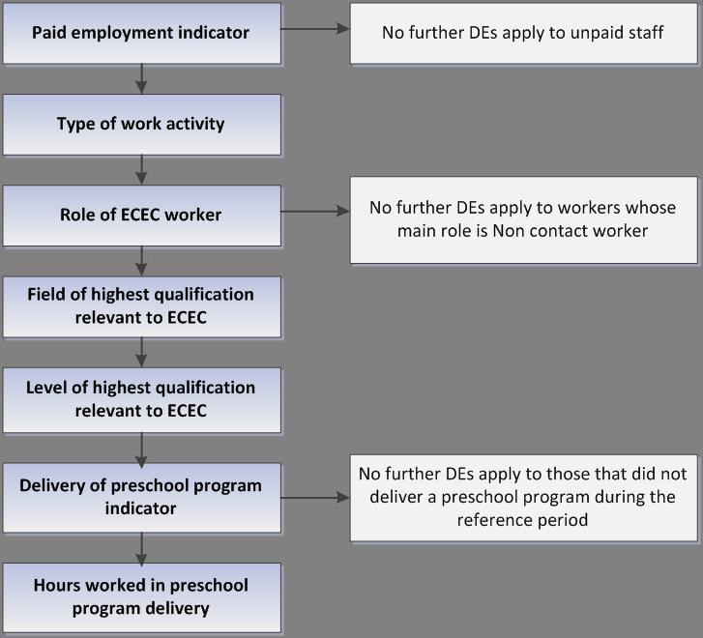

Source and reference attributes
Submitting organisation: | Early Childhood Data Sub Group (ECDSG)

Relational attributes
Related metadata references: | Has been superseded by Early childhood education and care worker cluster  Early Childhood, Superseded 08/04/2013
Implementation in Data Set Specifications: | Early Childhood Education and Care: Aggregate NMDS 2011  Early Childhood, Superseded 09/03/2012  Implementation start date: 01/07/2011  Early Childhood Education and Care: Unit Record Level NMDS 2011  Early Childhood, Superseded 09/03/2012  Implementation start date: 01/07/2011

Metadata items in this Data Set Specification
Seq No. | Metadata item | Obligation | Max occurs
1 | Person (employed)—paid employment indicator, code N  DSS specific information:  'Yes' includes early childhood education and care workers who receive wages or salary. They can include contract workers or relief workers.  'No' includes workers who are not paid, but who may be receiving in-kind benefits in recognition or exchange for their work. Unpaid staff may include volunteers, unpaid work trainees, parents and family members and students on work experience.  In-kind benefits such as free child care or the reimbursement of work-related expenses in full or part (for example, token payments or small gifts such as t-shirts) are not regarded as payment of salary, and people who receive these are considered to be unpaid workers. | Mandatory | 1
2 | Person (employed)—type of work activity, early childhood education and care, code N  Conditional obligation:  Conditional on responding '1 Yes' to whether the person is in paid employment. | Conditional | 1
3 | Person (employed)—role of early childhood education and care worker, code N  Conditional obligation:  Conditional on responding '1 Yes' to whether the person is in paid employment. | Conditional | 1
4 | Person (employed)—education field of highest relevant qualification, early childhood education and care, code N[N]  Conditional obligation:  Conditional on being a paid early childhood education and care contact worker. | Conditional | 1
5 | Person (employed)—level of highest qualification in early childhood education and care, code N[N]  Conditional obligation:  Conditional on being a paid early childhood education and care contact worker. | Conditional | 1
6 | Person (employed)—preschool program delivery indicator, yes/no/not stated/inadequately described, code N  Conditional obligation:  Conditional on being a paid early childhood education and care contact worker. | Conditional | 1
7 | Person (employed)—hours worked in preschool program delivery, total hours NNN  Conditional obligation:  Conditional on being a paid early childhood education and care contact worker who delivered a preschool program. | Conditional | 1

