Distress thermometer code N[N]
Exported from METEOR
(AIHW's Metadata Online Registry)
© Australian Institute of Health and Welfare 2024

This product, excluding the AIHW logo, Commonwealth Coat of Arms and any material owned by a third party or protected by a trademark, has been released under a Creative Commons BY 4.0 (CC BY 4.0) licence. Excluded material owned by third parties may include, for example, design and layout, images obtained under licence from third parties and signatures. We have made all reasonable efforts to identify and label material owned by third parties.
You may distribute, remix and build on this website’s material but must attribute the AIHW as the copyright holder, in line with our attribution policy. The full terms and conditions of this licence are available at https://creativecommons.org/licenses/by/4.0/.
Enquiries relating to copyright should be addressed to info@aihw.gov.au.
Enquiries or comments on the METEOR metadata or download should be directed to the METEOR team at meteor@aihw.gov.au.

Distress thermometer code N[N]

Identifying and definitional attributes
Metadata item type: | Value Domain
METEOR identifier: | 573491
Registration status: | Health, Standard 04/02/2015
Definition: | A code set representing the values on the distress thermometer.

Representational attributes
Representation class: | Code
Data type: | Number
Format: | N[N]
Maximum character length: | 2

Collection and usage attributes
Guide for use: | Using a visual distress thermometer (see the Collection methods section below for an example), ask the person to indicate the level of distress that they have experienced in the past week on a scale from 0-10, where 0 indicates ‘No distress’ and 10 indicates ‘Extreme distress’.  Valid values are 0 to 10.
Collection Methods: | Using the image below as a reference, patients are given the instruction “Circle the number (0-10) that best describes how much distress you have been experiencing in the past week including today" and are given the opportunity to circle a number on the paper or an electronic distress thermometer.  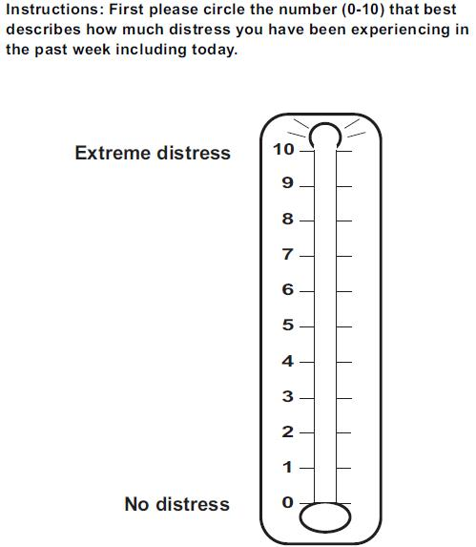
Comments: | The distress thermometer has been found to have reasonable sensitivity and specificity for general distress, depression and anxiety (Mitchell, 2007) and to be comparable, as a screening tool, with longer measures of psychological symptoms (Mitchell, 2010). It should be noted that while the distress thermometer is valuable as a screening tool, it is not a replacement for careful clinical assessment and management.  Reproduced with permission from the NCCN Clinical Practice Guidelines in Oncology (NCCN Guidelines®) for Distress Management (V.3.2012). © 2012 National Comprehensive Cancer Network, Inc. Available at: NCCN.org. Accessed [June 12, 2012]. To view the most recent and complete version of the NCCN Guidelines®, go on-line to NCCN.org.

Source and reference attributes
Submitting organisation: | Cancer Australia
Reference documents: | Mitchell AJ (2007). Pooled results from 38 analyses of the accuracy of distress thermometer and other ultra-short methods of detecting cancer-related mood disorder. Journal of Clinical Oncology,25:4670-4681.  Mitchell AJ (2010). Short Screening Tools for Cancer-Related Distress: A Review and Diagnostic Validity Meta-Analysis. Journal of the National Comprehensive Cancer Network,8:487-494.  National Comprehensive Cancer Network (2012). NCCN Clinical Practice Guidelines in Oncology: Distress Management. Retrieved from http://www.nccn.org/professionals/physician_gls/f_guidelines.asp

Relational attributes
Data elements implementing this value domain: | Person—distress status in past week, distress thermometer code N[N]  Health, Standard 04/02/2015

